5.n Implementing Necessary Components of Interface

5.n.m Router

React router is a powerful routing Library Based on react, which allows to quickly add views and data streams to the application, while keeping the page and URL synchronized.

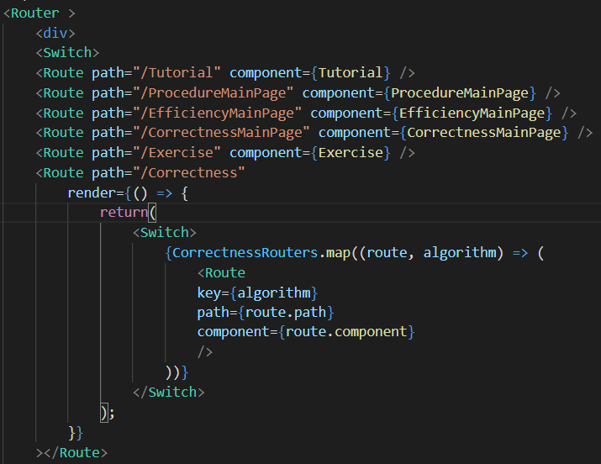

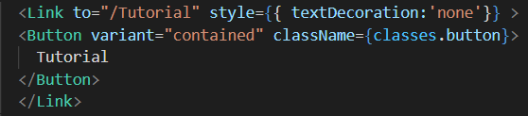

The specific method to use react router is to assign each interface a direct path. Every time a file wants to render an interface, just calls <Link> to link to the path of the interface. Although there are other ways which can also link to an interface, like <a href = “ ”> label. However, one property of router makes the interface loading more logical, it is history. Unlike <a> label using the absolute URL, because router is based on the history, which means it can store the history from last time visiting. In short, a history knows how to listen for changes in the browser's address bar, parse the URL and convert it into a location object, then the router uses it to match the route, and finally render the corresponding component correctly[2]. Based on the history, some information could be saved in the storage, it is helpful to make some components which require history to render, like study progress, last click and so on.

Reference

1. http://react-guide.github.io/react-router-cn/docs/Introduction.html

2. http://react-guide.github.io/react-router-cn/docs/guides/basics/Histories.html

3. URL(Uniform Resource Locator): On WWW, every information resource has a unified and unique address on the Internet, which is called URL (unified resource locator). It is the unified resource location mark of WWW, which refers to the network address.